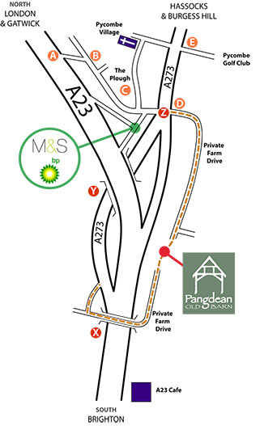
Pangdean Directions

What3Words App
Drive Entrance: ‘enchanted.pouting.wished‘
Barn entrance: 'forks.mirroring.messy‘

How to Find Us

Our official postcode is BN45 7FJ, but many sat nav systems seem to work better with BN45 7FN. Please don’t rely on a Sat Nav system for the very last part of your journey. Please read the details below and refer to our map, it will make your life a lot easier.

We are 5 miles North of Brighton, just off the main A23 London to Brighton Road. The entrance to our venue is down a long single track drive with passing places. The entrance to the drive is marked by green and white ‘Pangdean’ signs. The instructions below, when read in conjunction with the map should lead you directly to us. If you need any help or advice, please call us on 01273 84 33 02.

Heading North, On the A23 from Brighton, Patcham and the A27 (Eastbourne-Worthing):

Heading North away from Brighton on the A23 the road is 3 lanes wide. The left hand lane soon
becomes the A273 to Hassocks and Burgess Hill, while the centre and outside lane remain the A23 to Gatwick. STAY IN THE LEFT HAND LANE. The ‘A23’ transport cafe is on the Southbound carriageway to your right. Soon after this you pass under a small bridge (X) and then go through an underpass under the A23 (Y). 200m after the underpass there is a gap in the central reservation (Z). Turn RIGHT at this gap, across the southbound traffic, into the Pangdean Farm drive.

Heading South from London, Gatwick and the M25:

Leave Junction 7 of the M25 and head south on the M23 towards Brighton which becomes the A23 just south of Gatwick and Crawley. After approximately 20km, look out for the HASSOCKS exit onto the A273 at (A) on our map. Turn right at the end of the slip road (B). You pass under a bridge and have the Plough Pub on your left (C). The BP/Marks and Spencer garage is to your right. Carry straight on. You then come to a large T junction with the A273 (Z). Pangdean Farm Drive is STRAIGHT ACROSS from you (D) at this junction. Go straight over into the Pangdean Farm drive.

Coming from Hassocks, Burgess Hill, Ditchling in a Southern direction A273 (Jack and Jill):

Come down Clayton Hill on the A273 as if heading to Brighton. Pass the entrance to Three Greys riding school on your right, Pyecombe Golf Club € is then on your left. 300m later the road starts to widen out. Pangdean Farm is the next drive on your LEFT. Also at this point, there is a turning to the right signposted London. Ignore it. You need to turn LEFT into our drive. If you miss this entrance, carry straight on towards Brighton, go right around Patcham roundabout and go back on yourself, heading North on the A23. Follow instructions below.

If all else fails!:

Drive into the BP/Marks and Spencer garage and take a deep breath as you are only a couple of hundred yards away from us. Exit the garage from the exit to the right of the cash point. Turn LEFT on exit. In 100m you reach a T junction. TURN RIGHT. In 100m you come to another, much larger T junction with a dual carriageway (Z). Very carefully go STRAIGHT ACROSS both carriageways into the Pangdean Farm drive directly opposite you.

This is the entrance to our main driveway. Please keep left!

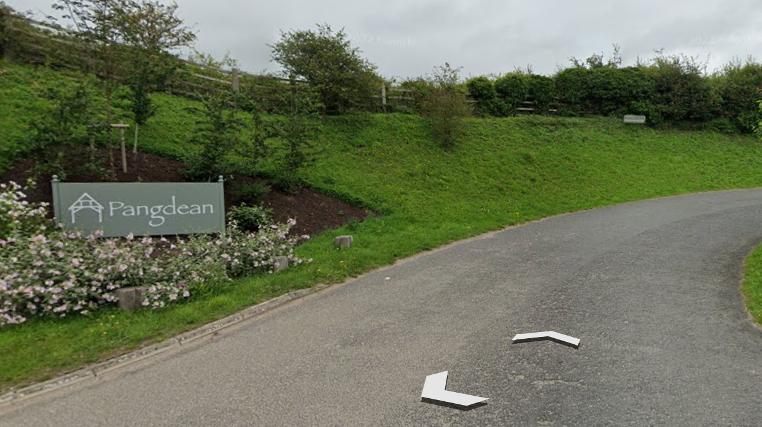

On Arrival at Pangdean:

Follow the long narrow drive down into the main farmyard. Pass the modern big green barns on your right and then the flint and brick house (The Cow Shed) on your left.
If attending an event you will be directed to the parking area beyond the main farmhouse. If you are visiting for a show round or a meeting, please park in the yard area.

